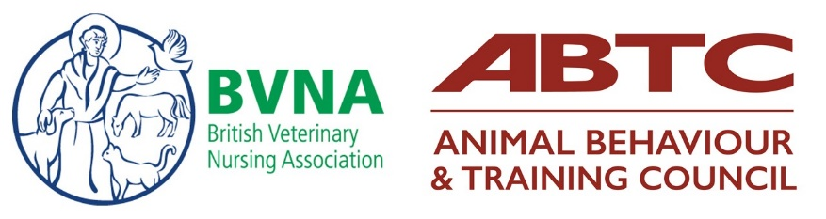
Learning Pathway in Behaviour
Access to the £125 special rate for new BVNA members

Thank you for your interest in the BVNA and ABTC Learning Pathway in Behaviour. These instructions are for non-BVNA members who wish to access the special rate of £125, by enrolling onto the Learning Pathway in Behaviour and signing up for BVNA membership at the same time.

Step 1: BVNA membership
Please sign up for BVNA membership here: https://bvna.org.uk/membership/
OR
If your practice are paying for both your course and membership, please indicate this on the form below.

Step 2: Contact us to request an invoice
Please complete the following form in full, as this will enable us to enrol you onto the course as quickly as possible. Please send the complete form to cpd@bvna.co.uk. We will then issue you/your practice with an invoice for the remainder of the course fee:

Cohort: | November 2022
Delegate Full Name
Membership Number (if applicable)
Full Address
Mobile Number
RVN Number
Date of Birth
Email Address
Practice Name and Address (for invoicing purposes)
Contact Name
Contact Email

Should you have any queries, please contact:

For course-related queries: Charlotte Bullard charlotte@bvna.co.uk
For administrative or enrolment queries: cpd@bvna.co.uk

